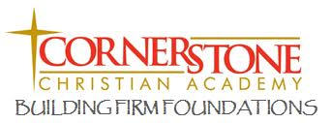
Volunteer Policy

Dear Parent(s),
As you know, this school year we implemented a new policy for staff & volunteer background checks for those who work with or around our students. This policy is meant to protect the safety and welfare of our students. The background checks are done through First Christian Church although we can accept an up to date background check from other sources such as an employer.
In working through this process, we have worked with our staff to clarify and adjust the guidelines we are using and will be using in the future.
First, background check forms are required for all people involved in (but not limited to) mentors, student teachers, chaperones, classroom and office helpers, preschools and other programs. In accordance with this Cornerstone policy, any person volunteering in a student supervisory capacity at Cornerstone Christian Academy are required to complete the background process.
Second, if you would like to volunteer in a non-supervisory capacity such as the Spring Carnival and classroom parties, a full background check will not be necessary. We consider the Spring Carnival a public event and therefore we do not feel it viable to require a background check to attend and volunteer. During a classroom party the teacher or staff responsible for the students will not leave the students unattended. Whether or not to require a full background check for future events is the responsibility of the CCA school board.
As always, you are welcome to call us with your questions or concerns at 812-446-4416. Again, all information is handled in a professional and confidential manner. Our mission is to offer the safest and healthiest environment for our students and we appreciate your time and patience during the process.
Sincerely,
Cornerstone Christian Academy School Board

